My Final Project, Scene 1

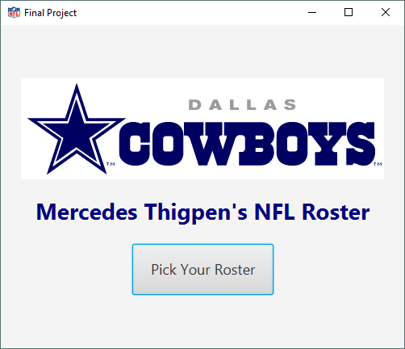

Pressing “Pick Your Roster” button opens to Scene2, the choiceScreen.

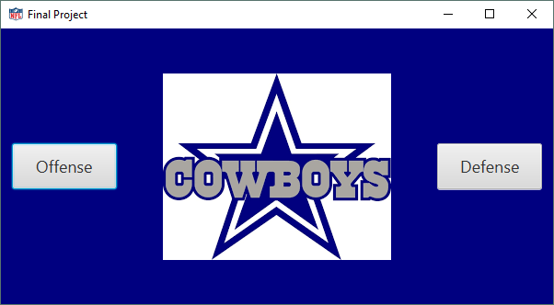

The user can choose between opening the Offense or Defense rosters.

When the “Offense” button is pressed, the offenseScene is displayed. The user can view player information and select players. When “Remove from Roster” button is pressed, the players are deleted from the listing.

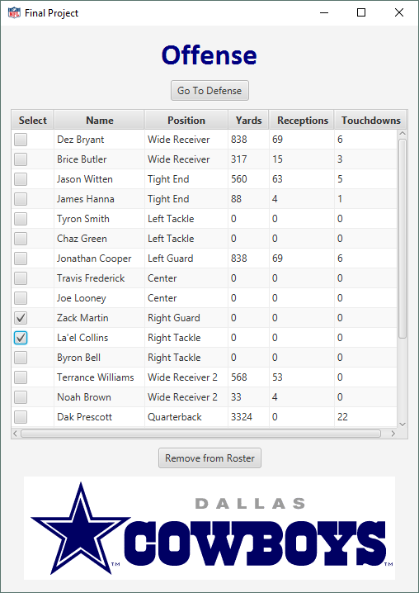

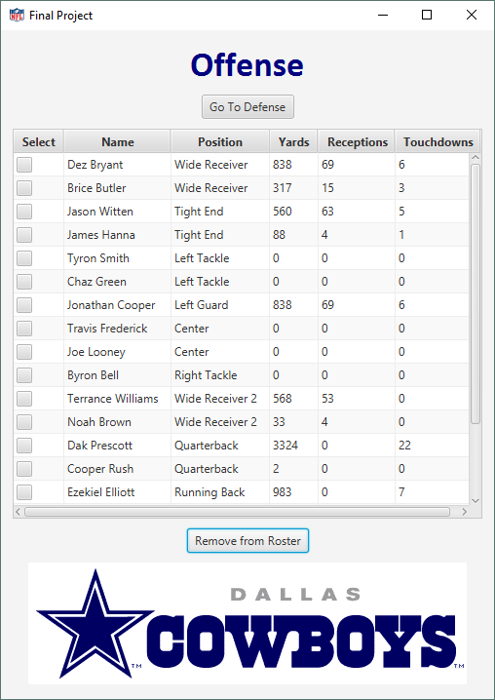

Pressing “Go To Defense” button, opens the defenseScene.

When the “Defense” button is pressed, the defenseScene is displayed. The user can view player information and select players. When the “Remove from Roster” button is pressed, the players are deleted from the listing.

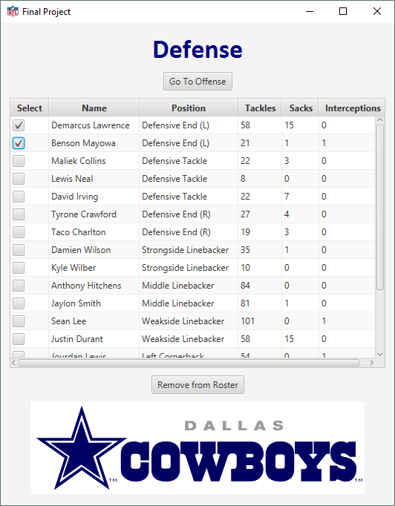

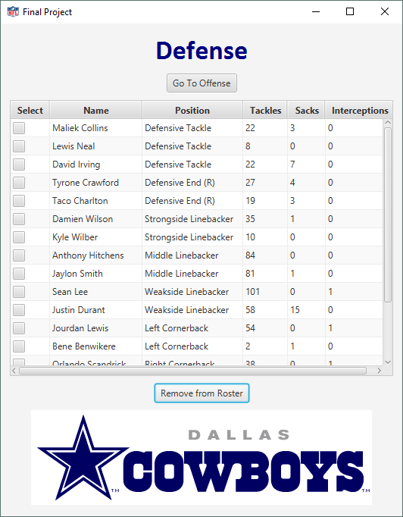

Pressing “Go To Offense” button, opens the offenseScene.

End of Program.